Terms of Reference
Articulating the Outcomes of the Act Together for Inclusion Fund (ACTIF)
October 2026
Background
Dignity Network Canada (DNC) is a Canadian network working to advance the human rights, dignity and equality of LGBTQ2I+ people internationally by strengthening connections, solidarity and collaboration between Canadian and global LGBTQ2I+ movements. Equitas – International Centre for Human Rights Education (Equitas) is a Canadian human rights organization with extensive experience in human rights education, capacity strengthening and movement-based approaches to advancing equality and inclusion.
DNC and Equitas established a strategic partnership to provide joint oversight and stewardship of the Act Together for Inclusion Fund (ACTIF), an innovative multi-year program funded by Global Affairs Canada (GAC), recognizing the value of bringing together DNC’s movement-building and international LGBTQ2I+ solidarity expertise with Equitas’ experience in human rights education, organizational strengthening and international partnerships.
Conceived in 2019 and launched in 2020, ACTIF emerged within a particular Canadian and global context, with specific conditions and considerations that informed its design, partnerships, objectives, and approach to supporting LGBTQ2I+ communities and movements internationally. Over the subsequent years, the context in which ACTIF has been implemented has evolved significantly. Global political, social and funding environments have shifted to adapt to persistent backlash and coordinated anti-gender movements, as have approaches to LGBTQ2I+ rights, international solidarity, movement building and Canada’s role in supporting LGBTQ2I+ communities and movements abroad.
Throughout its nearly seven years of implementation, ACTIF launched four calls for proposals through its primary funding mechanism, supporting 20 projects. It also funded four short-term initiatives through its Emerging Opportunities Fund and supported two special projects under its Inclusion Strategy. By 2027, the Fund will have moved $10,000,000 to 66 civil society organizations based in Canada and abroad, enabling change on global LGBTQ2I+ rights in the global South and East. Beyond direct project funding, the program facilitated numerous events, convenings, and collaborative spaces, and contributed to the development of a range of knowledge products. ACTIF is now in its final year of implementation, with the program scheduled to conclude in March 2027.
Overview
As ACTIF reaches an important moment in its evolution, DNC and Equitas wish to commission a rapid independent study to document and understand its outcomes. This rapid study will map the outcomes achieved during the final approximately two years of ACTIF implementation (from 1 December 2024 to 15 December 2026). It will also synthesize these findings with the results already documented through ACTIF’s Mid-Term Evaluation (see Additional information below).
We are asking the Consultant to focus primarily on mapping and articulating outcomes at the project level, expressing them against the ACTIF Theory of Change (see Annex 1).
In addition to project level outcomes, Equitas and DNC further ask the Consultant to assess the lessons learned and outcomes stemming from the strategic partnership between Equitas and DNC over the life of ACTIF, so that these lessons may be incorporated into future programming and funding models.
While this consultancy requires a skilled researcher and evaluation experience, skills, and accreditation will be considered strong assets, it is not intended as a formal or comprehensive evaluation exercise. ACTIF’s Mid-Term Evaluation has already assessed the program against the OECD DAC criteria of relevance, effectiveness, efficiency, and sustainability, and provided a series of recommendations based on those findings.
The purpose of this mandate is therefore not to replicate that work, but rather to document and synthesize outcomes achieved during the final phase of the program and to situate them within the broader results already identified. More specifically, it seeks to provide an updated snapshot of ACTIF in its final year, with a primary focus on program-level results, by:
- Mapping and articulating outcomes supported across the Fund in the last approximately two years;
- Collating and synthesizing key quantitative data across the Fund, where data is available.
- Articulating partner narrative reporting into higher level outcome reporting against the ACTIF Theory of Change;
- Conducting case study research resulting in the publication of six concise case studies.
Additional information
The Act Together for Inclusion Fund is a cornerstone of GAC’s LGBTQ2I International Assistance Programme, which represents a 2019 commitment by the Government of Canada to invest at least $30,000,000 into global LGBTQ2I+ rights programming, followed by at least $10,000,000 per year.
A Mid-Term Evaluation of ACTIF was published in mid-2025. Data gathering for the assessment was completed in December 2024.
Purpose and Scope of Work
The study will map and analyze the key milestone moments in the development and implementation of ACTIF from the start of December 2024 to mid-December 2026 and integrate those outcomes with the results of the Mid-Term Evaluation completed in December 2024. The study should identify the decisions, relationships, conditions, adaptations and contributions that enabled the initiative to achieve its objectives and evolve over time.
The study will also provide a forward-looking reflection on where ACTIF and the broader LGBTQ2I+ movement-building ecosystem are situated in 2026, particularly from a funding, partnership and movement-building perspective, and identify contributions and considerations emerging from ACTIF that may inform future Canadian and international efforts.
Objectives
- Develop a timeline of key moments that shaped the development of ACTIF.
  - Contextualize the start of the initiative: Reconstruct and assess the conditions and considerations present in 2019 when ACTIF was conceived and funded, including the policy, resources, and movement contexts that shaped its original design and expectations.
  - Contextualize the end of the initiative: Examine ACTIF’s contribution to strengthening DNC’s network and LGBTQ2I+ movement in Canada, particularly its role in building resources, collaboration, and knowledge that can support LGBTQ2I+ communities and movements internationally.
- Analyze key outcomes, since the December 2024 data cut-off of the Mid-Term Evaluation, against the ACTIF Theory of Change, drawing together partner narrative reporting into higher-level findings across its Results Areas to present a coherent account of the Fund’s overall contribution from 2020 to 2026.
- Examine ACTIF’s contribution to strengthening DNC’s network and the growth of LGBTQ2I+ movements in Canada and internationally, including the role of relationships, knowledge, solidarity, capacities, connections and allyship in supporting LGBTQ2I+ communities and movements. This includes exploring how Equitas and other allies have contributed to ACTIF’s development and outcomes, and how allyship can support locally-led, sustainable and connected movement building.
- Identify the principal lessons, contributions and enabling conditions regarding strategic partnerships emerging from ACTIF, focusing mainly on the Equitas-DNC partnership, including what has worked, what has evolved, what should be sustained, and what could be adapted in future partnerships. (Note that lessons around the programming model were tackled in the Mid-Term Evaluation.)
- Answer the following three key questions:
  - What have been the key outcomes supported by ACTIF over the past two years (i.e. since the Mid-term Evaluation)?
  - What are some critical examples of the contribution of ACTIF outcomes to wider pro-democratic and human rights pushback?
  - What is the quantifiable reach and impact of ACTIF overall?
Expected Deliverables
- A concise milestone, outcomes and learning report (suggested, c15 pages), supported by a visual timeline or milestone map, documenting ACTIF’s evolution, key contributions, contextual shifts and lessons learned, with clear forward-looking considerations for DNC, Equitas and partners.
- Six case studies, written in a compelling, user-friendly style, and supplied as annexes to the report (and which will later be published as interactive webpages):
  - one focused on the core partnership between Equitas and DNC that delivered ACTIF and;
  - five highlighting compelling program-level outcomes, preferably reflecting the five Results Areas of the ACTIF Theory of Change.
All written outputs of the consultancy are expected to be delivered in English. The Consultant will follow the format, structure and length defined by Equitas and DNC.
The Consultant will report contractually to the Senior Manager, ACTIF, who will be responsible for the oversight and management of the contract. The DNC Director of Programmes, Partnerships, and Learning will be the Consultant’s primary point of contact for guidance on the execution of the mandate and support with the development of deliverables. The quality of the deliverables will be assessed by both the Senior Manager, ACTIF and the DNC Director of Programmes, Partnerships, and Learning.
Desired Timelines
Activity | Estimated Timeline
Selection and contracting of consultant; inception meeting; review of relevant ACTIF and contextual documentation; refinement of methodology and workplan. | Mid-November 2026
Document review and key informant interviews with ACTIF partners, DNC, Equitas, funders, allies, and other relevant stakeholders; initial identification of milestone moments; submission of case study one (first draft). | December 2026
Analysis of findings; development of the ACTIF milestone timeline/map; assessment of contextual changes, movement-building contributions, allyship and funding environment. | Mid-January 2026
Submission of draft milestone, outcomes and learning report with its annexes to DNC and Equitas for review and feedback. | End January 2027
Validation and reflection sessions with key stakeholders; incorporation of feedback; finalization of findings, lessons and forward-looking considerations. | Early February 2027
Final editorial review, design and preparation of the publication. | Late February 2027
Publication of the rapid study. | March 2027
Duration and Location
The assignment is to be conducted between October 2026 and February 2027. The estimated maximum level of effort is 35 days.
The assignment is expected to be home-based with all meetings to be virtual. The Consultant is responsible for all necessary equipment required (e.g. computer, phone, internet, etc.).
Qualifications and Assets
- Demonstrable experience in conducting evaluations of international projects that focus on issues of LGBTQ2I+ human rights and gender equality in Canada and internationally;
- Familiarity with Global Affairs Canada’s – or similar funding institutions’ – accountability frameworks and reporting mechanisms;
- Understanding of the context in which ACTIF has been operating and the needs and challenges;
- Familiarity working with theories of change and logic models;
- Ability to conduct high-quality evaluations, meet deadlines and respond to requests and feedback provided timely and appropriately;
- Strong analytical and conceptual skills to clearly synthesize and present findings, draw practical conclusions, make recommendations and to prepare well-written reports in a timely manner;
- Ability to skillfully navigate complex and evolving challenges regarding risk and security issues faced within frontline movements, with the need to produce human-centric data which communicates and humanizes impact;
- Works well in a team to advance the goals of ACTIF, including openness to constructive feedback and focus on results for the client;
- Excellent organizational skills and ability to manage the available time and resources;
- Ability to communicate and work in English. Ability to communicate and work in French is considered an asset.
Budget
Expressions of interest are called for under a consultancy fee budget of CA $26,250.
Costs for interpretation, as some interviews may need to be conducted in French and/or Spanish, will be covered separately, with a current budget ceiling of CA $750-1,000.
Costs for graphic design and production of the final publication will be managed and covered separately by Equitas and DNC.
How to Apply
Applicants must submit the following documents as part of their proposal:
- Letter of Interest, including confirmation of availability in the timeframe indicated and highlighting how the Consultant/team meets the required expertise and qualifications listed;
- Full proposal showing fulfilment of the requirements listed in these Terms of Reference;
- Total consultancy fees (in CA$ - before and after taxes);
- CV, including portfolio of previous work relevant to this mandate;
- At least two recent and relevant references for similar mandates.
Consultants with the desired experience are invited to contact the ACTIF team at
actif-agiri@equitas.org, with “ACTIF Rapid study” in the subject line.
For further information about Equitas, consult our website at www.equitas.org.
Deadline for proposals: November 4th, 2026, 5:00 PM (Eastern Time).
Incomplete proposals will not be considered. Equitas will contact shortlisted candidates only.

Annex
Annex 1 – Overview of the ACTIF Theory of Change

Annex 1
Overview of the ACTIF Theory of Change
The Act Together for Inclusion Fund (ACTIF) is a funding modality and collaborative effort to contribute to enhanced respect for and protection and fulfillment of the human rights of LGBTQ2I persons internationally.
Acting together with partners, and wider organizations and communities, ACTIF aims to help build shared equity in support of change at various scales.
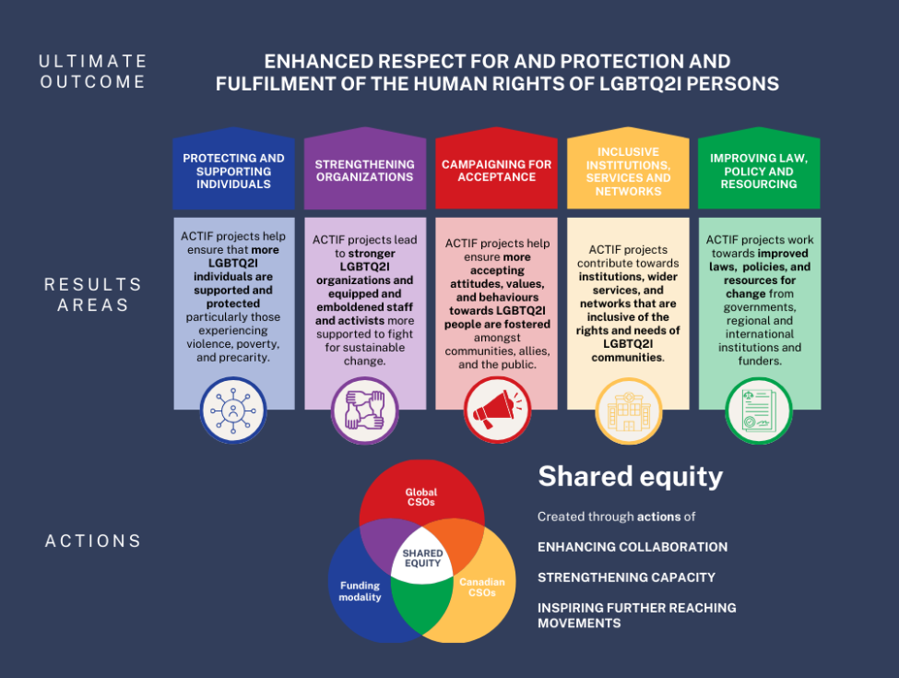

Results Areas
Funded projects contribute towards the ultimate outcome of the ACTIF through five Results Areas. These areas are mutually complementary; changes in one area will facilitate changes in the other four areas.
All currently funded ACTIF projects contribute to multiple Results Areas. It is likely that future funded projects will similarly contribute to multiple Results Areas.

- Protecting and Supporting Individuals

ACTIF projects help ensure that more LGBTQ2I individuals are supported and protected particularly those experiencing violence, poverty, and precarity. Under currently funded projects, this support and protection consists of greater access to:
- Psychosocial, legal, advocacy, healthcare support, or access to guidance or information for individuals;
- Support services for victims/survivors of violence, abuse, and discrimination;
- Support for individuals experiencing or at risk of violence, displacement, or homelessness to seek pathways to safety and, ultimately, be in safer spaces;
- LGBTQ2I individuals’ access to capacity-building efforts such as training, internships, employment or skills-building opportunities, or wider development programs (e.g., focused on leadership, entrepreneurship, microcredit, or safety nets).

- Strengthening Organizations

ACTIF projects lead to stronger LGBTQ2I organizations and equipped and emboldened staff and activists more supported to fight for sustainable change. Under currently funded projects, such work strengthening organizations includes:
- Training for staff of ACTIF-funded CSOs, and wider CSOs and community groups (for example, concerning leadership, litigation, advocacy, management, communications, and different subject matter areas);
- Growth in organizational scope, operations, or resources (for example, new programs, policies, organizational learning, strategy, or services);
- New organizational relationships;
- Supporting wider organizations or community groups serving LGBT2I communities (e.g., financial support, technical assistance, coalition-building, etc.).

- Campaigning for Acceptance

ACTIF projects help ensure that more accepting attitudes, values, and behaviours towards LGBTQ2I people are fostered amongst communities, allies, and the public in general. Under currently funded projects, such work campaigning for acceptance includes:
- Increasing public access to key messages and campaigns developed by LGBTQ2I communities and movements;
- Improving individual journalists’ and organizational media practices concerning reporting on LGBTQ2I rights issues;
- Working with specific communities or sectors to increase understanding and compassion towards LGBTQ2I communities.

- Inclusive Institutions, Services, and Networks

ACTIF projects contribute towards institutions, wider services, and networks that are inclusive of the rights and needs of LGBTQ2I communities. This helps create more inclusive environments, in which LGBTQ2I people are more protected and can access support. Under currently funded projects, this includes increased attention to LGBTQ2I rights and needs in:
- Institutions acting in a wide range of thematic areas in which LGBTQ2I rights and needs are often neglected. For example, in employment, healthcare, education, housing, and justice, and in social institutions, such as families and faith settings.
- Services or other support mechanisms offered to LGBTQ2I communities via wider non-profit or private sector actors.

- Improving Law, Policy, and Resourcing

ACTIF projects work towards improved laws, policies, and resources for change. This includes work towards influencing governments, regional and international institutions, the judiciary, human rights bodies, wider policy makers, and funders, so LGBTQ2I human rights are more fully addressed. Under currently funded projects, this includes:
- Changes to laws or government or regional/international institutions’ policy through advocacy or other influencing work;
- Changes to law or jurisprudence through strategic litigation;
- Research or strategy development to inform and facilitate these changes.

Actions

- Enhancing collaboration

The ACTIF is developed on an assumption that partners will come together to create change, and that capacity is built through that collaboration, in turn contributing to improved reach and impact of movements – all of which contributes to the ACTIF’s ultimate outcome. Enhanced collaboration is therefore at the very core of how the ACTIF works and what it seeks to achieve.
Our concept of enhanced collaboration draws on a strengths-based approach and on abundance thinking. In other words, everyone has something important to contribute to processes of collaboration and change and, by working together effectively and equitably, we will generate shared equity which supports further change of benefit to all.
Key elements of this shared equity are high-trust and mutually beneficial relationships, strengthened capacity and greater reach of movements.
By the end of the programme, the ACTIF will have therefore helped build
- Enhanced collaboration
A stronger set of collaborative relationships amongst Equitas, DNC, Canadian CSOs, global South/East CSOs, and wider partners involved in delivering outcomes.

- Strengthening capacity

‘Capacity development is the process through which individuals, organizations and societies obtain, strengthen, and maintain the capabilities to set and achieve their own development objectives over time.’

The ACTIF strengthens the capacity of all actors involved to address the human rights of LGBTQ2I persons globally, in ways that are relevant, representative, and accountable.
This strengthened capacity consists in increases in capabilities at the individual level (e.g., in knowledge, skills, and confidence to address the rights and needs of LGBTQ2I communities) organizational level (e.g., improved programmes, strategies, or systems), and wider network or societal level (e.g., increased networks of peers and allies to call on for support).
Importantly, strengthened capacity also consists in increased quality, reach, and depth of relationships with marginalized LGBTQ2I individuals and communities; increased knowledge and understanding of their needs; and increased capacity to develop relationships and learning together with others.
Capacity strengthening is a mutual process which flows in multiple directions. For example:
- Global CSOs (based in the Global South and East) help build the capacity of fund partners, through i) contributing insight and expertise concerning the rights and needs of marginalized LGBTQ2I communities, including strategies for addressing those rights and needs; ii) working alongside individuals and communities to enhance the range of voices represented in programming; and iii) holding Canadian CSOs and ACTIF staff accountable for supporting relevant and representative programming. In turn, Global South/East CSOs benefit from increased (and relatively stable) multi-year financial investments, and improved access to learning and relationship-building opportunities.
- Canadian CSOs contribute by offering relatively stable organizational systems and resources, technical assistance, and opportunities to build relationships and share learning with programming and wider partners. Through their own programme and organizational development, peer learning, and through contributing to the improvement of the ACTIF and of GAC’s LGBTQ2I work, they also contribute to creating an increasingly capable, open, transparent, impactful, and accountable Canadian global LGBTQ2I sector.
- ACTIF as a funding modality contributes financial resources, and a relevant and sufficiently flexible grantmaking system, towards capacity strengthening efforts designed by Global South/East and Canadian CSOs. It also contributes a programme-level monitoring, evaluation and learning system, which incentivizes reflective evaluation and learning practices, and offers opportunities to share learning across the programme. It benefits from increased exposure to, and opportunities to learn from, LGBTQ2I-led and Global South/East-focused programming efforts. Over time, it can also draw on impact reach, and relationships of partners to appeal for further support of benefit to all.
This strengthened capacity ensures LGBTQ2I CSOs and CSO networks are better placed to deliver stronger outcomes over time, and to withstand adverse conditions, including after specific projects have ended.
This strengthened and more sustainable capacity will also support outcomes via other pathways. For example, it will support CSOs to deliver more effective advocacy, influencing, campaigning, and individual support and protection efforts. It will also support partners to develop better quality and further reaching relationships and networks, in support of further change.

By the end of the programme, the ACTIF will have therefore helped build
- Strengthened capacity
Strengthened individual and organizational capacity to deliver outcomes for LGBTQ2I persons internationally, including in ODA eligible countries.

- Further reaching movements
A third aspect of building shared equity is shared efforts to expand the reach of LGBTQ2I movements, to address the rights and needs of LGBTQ2I persons. Expanding reach involves developing new and strengthened networks that can support individuals and organizations to appeal for broader change, particularly at regional and international levels. It also involves addressing new and strengthened intersections between LGBTQ2I human rights and a wider range of:
- Issues (e.g., development, humanitarian response, peacebuilding, wellbeing, arts and culture, and other strategic priorities as developed by partners);
- Inequalities (e.g., gender equality, trans, intersex, ethnicity, indigeneity, etc.);
- Institutions (e.g., government and private donors and funders, international human rights, development, and humanitarian response systems).
These acts of reaching further, and the goals they achieve, will help build movements that are more visible and relevant to a wider range of community and policy settings, and agendas for change. These further reaching movements will achieve advocacy and campaigning goals which are strategic, sustainable, and coherent, and therefore more likely to provide further levers for change.
As a demand-driven programme the precise character of these new and strengthened networks and intersections will be determined by programme partners and the communities they work alongside.
By the end of the programme, the ACTIF will have therefore helped build
- Further reaching movements
An international LGBTQ2I movement – including a Canadian global LGBTQ2I sector – that is better networked, and better placed to deliver change across a further reaching range of issues, inequalities, and institutions.

i.e., not including improvements to ACTIF funded CSO services or support mechanisms, which should be tracked as a strengthening capacity outcome.
We understand a strengths-based approach as a way of emphasising the contribution, strengths, and/or assets actors bring to a shared effort.
Abundance thinking helps us imagine relationships and worlds in which there will always be more, we are generous with our contributions and ideas, we can embrace change, and work together to ‘grow the pie’. It is often contrasted with scarcity thinking, which imagines relationships and worlds in which there will never be enough, and actors expect to compete against one another for limited or shrinking resources. This also builds on our understanding of a human rights-based approach which avoids hierarchical and conflictual (or ‘zero sum’) conceptions of rights.

